

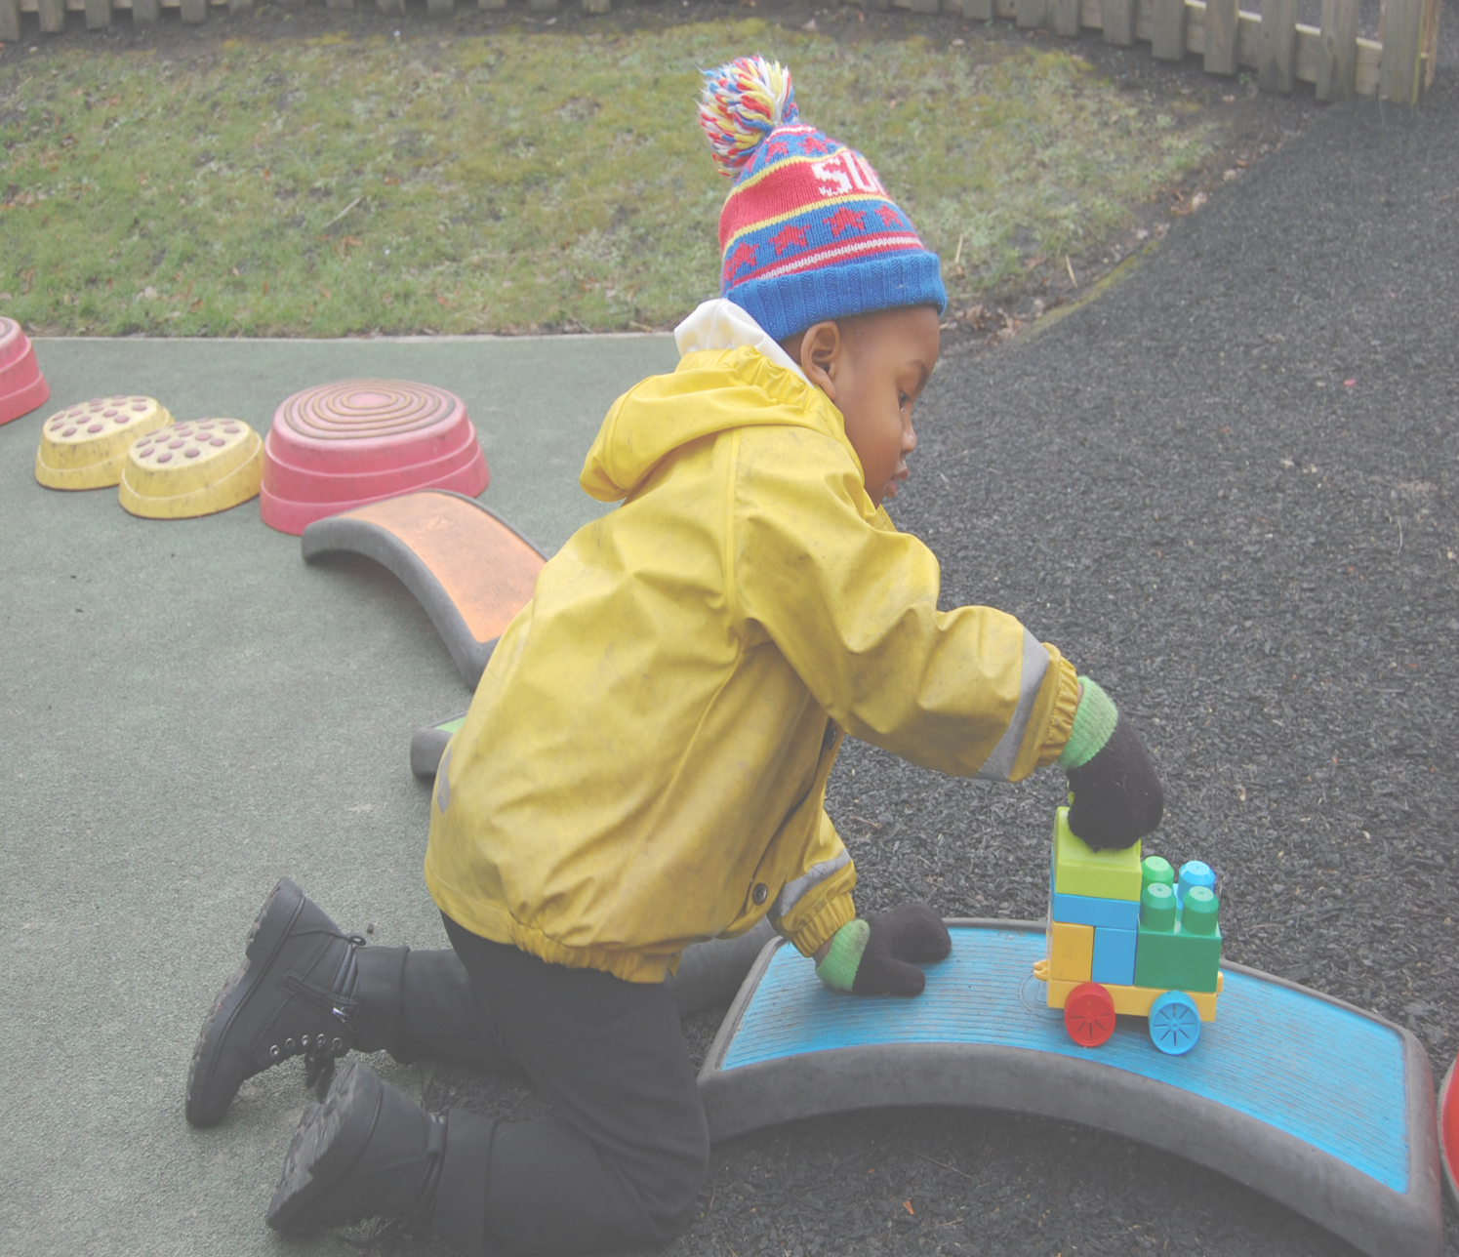

Netherton Park- ’foundations to flourish’.
High quality learning through Play.
Inspiring and Nurturing children to become creative, confident and caring individuals.
supporting families and partnerships in an inclusive, safe and stimulating environment .

Netherton Park Nursery School
EYPP strategy statement
2025-2026
‘A place where children are at the heart of
learning’

This statement details our Nursery School’s use of Early Years Pupil Premium funding to help improve the attainment of our disadvantaged pupils.
It outlines our Early Years Pupil Premium strategy, how we intend to spend the funding in this academic year and the outcomes for disadvantaged pupils last academic year.

School overview
Detail | Data
Number of pupils in Nursery School eligible for EYPP | Autumn term 2025  Acorn – 13/29  Saplings – 12/23  Oak – 17/48  Sycamore – 7/12  Spring term 2026  Acorn – 16/38  Saplings – 11/25  Oak – 15/47  Sycamore –7/12  Summer term 2026  Acorn – 16/38  Saplings – 10/25  Oak – 15/47  Sycamore -7/12
Proportion (%) of pupil premium eligible pupils | Autumn term 2025 - 44%  Spring term 2026 – 40%  Summer term 2026 – 40%
Academic year that our current Early Years Pupil Premium strategy plan covers | 2025-2026
Date this statement was published | December 2025
Date on which it will be reviewed | July 2026
Statement authorised by | Alison Ward - Headteacher
EY Pupil Premium leads | Alison Ward - Headteacher  Kerry Chesworth – Early Years Lead Educator
Governor | Chris Booker – EYPP Governor

Funding overview
Detail | Amount
Early Years Pupil Premium funding allocation this academic year | Autumn term 2025 - £10,290  Spring term 2026 - £9,000  Summer term 2026 - £  Total: £19,290
Early Years Pupil Premium funding carried forward from previous years | £0
Total budget for this academic year | £19,290

Part A: Pupil premium strategy plan

Statement of intent
At Netherton Park Nursery School our aim is that all pupils, irrespective of their background or potential challenges, have a great start, make strong progress and achieve well across all areas. This then enables them to have the best possible life chances and prepares them well for the next stage in their education. We believe that this early preparation builds the foundations of their success as they move through life. We are very mindful that some pupils who are not eligible for EYPP funding but may still be disadvantaged or vulnerable. We therefore support all pupils to make the best progress they can from their individual starting points and to achieve the best they can academically, physically, socially and emotionally regardless of their background.
‘Schools do not have to spend pupil premium so it solely benefits eligible pupils. They can use it wherever they identify the greatest need.’ ‘Using pupil premium funding to improve teaching quality is the most effective way to improve outcomes for disadvantaged pupils. By doing so, schools will inevitably benefit non-eligible pupils as well.’ ‘Schools may wish to use a portion of PPG funding to support pupils who do not meet any of the PPG eligibility criteria but have other identified needs, where they deem it beneficial to do so.’ ‘Using Pupil Premium: guidance for school leaders’ March 2022.
High quality provision is proven to be the key driver for raising attainment for all children including those at risk of disadvantage. Our commitment is to ensure that the Nursery School is a place where EVERY child can thrive.
Our strategy is to identify the key actions for individuals and groups of children that will make the biggest difference. Leaders are familiar with up-to-date research and use this to inform decisions. The strategy, interventions and actions are regularly reviewed and adapted to meet needs.
Early Years Pupil Premium | EEF

Challenges
This details the key challenges to achievement that we have identified among our disadvantaged pupils.
Challenge number | Detail of challenge
1 | On entry assessments for disadvantaged pupils, including Wellcomm screening, evidences Communication and Language skills are significantly below age related expectations.
2 | On entry assessments for disadvantaged pupils evidences PSED skills are significantly below age related expectations.
3 | On entry assessments for disadvantaged pupils evidences Physical skills are significantly below age related expectations.
4 | Parental engagement is lower for disadvantaged pupils – particularly for EAL families.
5 | Disadvantaged pupils often have limited life experiences compared to their non-disadvantaged peers. This is often linked to poverty. This lowers their world knowledge and experiences and vocabulary exposure. Pupils are not on an equal starting point from their peers due to this.

Intended outcomes
This explains the outcomes we are aiming for by the end of our current strategy plan, and how we will measure whether they have been achieved.
Intended outcome | Success criteria
Improved Communication and Language skills for disadvantaged pupils. | Attainment and progress: All children make at least expected progress from their individual starting points, with the majority making better than expected (rapid) progress.  Use of language and vocabulary in everyday interactions: Observations show that children consistently use a widening vocabulary and are able to express their needs, wants and ideas clearly. Quality of back-and-forth interaction: Children initiate and sustain back-and-forth conversations with adults and peers, demonstrated by:  - taking turns in conversations  - responding appropriately to questions and comments  - maintaining focus in interactions for an age appropriate length of time
Improved Personal, Social and Emotional skills for disadvantaged pupils. | Wellbeing and emotional security: By the end of the year the majority of children will present as settled, secure and able to separate from their main carer, with incidents of high distress or dysregulation in nursery reduced from baseline.  Engagement and participation in learning: children engage in play and adult-led activities, showing improved concentration and participation compared with their starting points.  Improved self-regulation and managing feelings: By the end of the year, children with emerging social, emotional and behavioural needs are increasingly able to identify and manage their feelings, with a reduction in incidents of dysregulation and the need for adult intervention compared to baseline.  Stronger relationships and positive interactions: Key person observations show that children are forming and maintaining positive relationships with adults and peers, showing increased turn-taking, sharing and cooperative play, and fewer incidents of conflict or isolation.  Increased engagement in routines and learning: Children are more consistently following nursery routines and expectations, with sustained engagement in play and small-group activities and a noticeable improvement in their ability to participate fully in learning experiences.
Improved Physical Development skills for disadvantaged pupils. | Assessments and observations indicate significantly improved age related expectations being achieved by disadvantaged pupils.
Improved engagement from parents of disadvantaged pupils, especially EAL families. | Increased family confidence and engagement: Attendance, at sessions and parent/carer feedback (e.g. questionnaires, workshops, informal conversations) shows that families feel more confident and better equipped to support learning at home through play, talk, reading and everyday experiences.  Regular use of home learning opportunities: Sharing of library books, Tapestry engagement and interventions eg Early Talk Boost, Borami indicate that a growing number of families are regularly engaging with suggested home learning, with increased participation over the year.  Stronger progress linked to home–nursery consistency: Assessment data shows that children whose families engage with home learning make at least expected progress, and many make better than expected progress, across multiple areas of learning.
A broad range of life experiences offered to disadvantaged pupils. | Increased access and participation: All children have regular access to planned enrichment experiences (e.g. visitors, outdoor and cultural activities) across the year, with high levels of participation  Broader world knowledge and curiosity: Most children are increasingly able to notice, comment on and recall new experiences and environments, demonstrating broader world knowledge and curiosity compared to their starting points.  Richer language and confidence to talk about experiences: The majority of children are using a wider range of vocabulary to describe places, people, events and feelings, and are more confident initiating conversations and talking about the wider world and recent experiences in nursery and at home (as reported by parents/carers).

Activity in this academic year
This details how we intend to spend our pupil premium funding this academic year to address the challenges listed above.

Teaching
Budgeted cost: £4,000
Activity | Evidence that supports this approach | Challenge number(s) addressed
Forest School training AP and HYS  Supply cover to complete training and portfolio  INSET for all staff | Forest School for Wellbeing school and practititioner booklet LR_compressed.pdf  Guide-to-Effective-Professional-Development-in-the-Early-Years.pdf  A total of 3 staff are trained in Forest School (2 at Level 3 and 1 at Level 2).  Whole staff training to support Nature Play sessions.  All pupils attending weekly Nature Play sessions from the Spring term. | 1, 2, 3
Tales Toolkit training and resources  INSET for all staff | Tales Toolkit - pilot | EEF  Supporting Early Literacy in the Early Years | Education Endowment Foundation  Guide-to-Effective-Professional-Development-in-the-Early-Years.pdf  Tales Toolkit training for staff to support children with storytelling skills – developing language and vocabulary.  Regular sessions embedded into Oak (Acorn and Saplings for the Summer term).  Working closely with EYFS staff at NRPS. | 1,2

Targeted academic support
Budgeted cost: £10,290
Activity | Evidence that supports this approach | Challenge number(s) addressed
Additional staffing to support disadvantaged pupils – including delivery of specific interventions and targets linked to SEN plans and Wellcomm as well as with managing emotions and self-regulation | High-quality interactions | EEF  A higher staff ratio provides all children with more adult interactions and scaffolding across the nursery school. This leads to more quality interactions, children observe more modelling of play and language and have role models to show them how to interact, play and become fully involved. Having more staff available allows more scaffolding in the moment and opportunities for targeted interventions and small group work. | 1,2,3
Early Talk Boost | Supporting Communication and Language in the Early Years | Education Endowment Foundation  Pupils in Oak identified for Early Talk Boost intervention – delivered by AW  All pupils screened using Wellcomm - interventions identified for individuals and groups as well as embedding high quality conversations and language development into the curriculum and environments | 1,2
Wellcomm speech and language screen and interventions |  | 1
Boromi Bags – home learning intervention  Early Excellence home lending bags | Children using Boromi experience significant improvement in communication and other key skills - SHINE  EEF_Parental_Engagement_Guidance_Report.pdf  Boromi bags used with Saplings (Autumn and Spring term, and Acorn Summer term). Families borrow bags for 2 nights to use at home.  Early Excellence home learning bags purchased to used as a complimentary tool alongside the Boromi bags to support with engagement with parents and to further develop Communication and Language skills. | 4,5
Review of UTW curriculum – audit of resources to deliver the curriculum | Curriculum reviewed and resources identified to ensure the curriculum is delivered effectively. | 1,2,3
Review of EAL processes and engagement with parents | Staff develop a range of strategies to support all families including using translated information on Tapestry and in other forms of communication with parents. | 1,4
Bikeability – physical intervention | Cycle Training for Everyone - Deliver Safer Training | Bikeability  Supporting Physical Development in the Early Years | Education Endowment Foundation  All children need to be confident in their gross motor skills and movements. This may increase children’s development of muscular strength, ability to take well intentioned, safe risks and become increasingly well-coordinated. Gross motor skills affect wellbeing and give children opportunities to socialise in play. Confidence and coordination in gross motor skills are essential for children in developing their fine motor skills.  Parents will attend sessions with their children – supporting parental engagement. | 1,2,3,4,5
SMILE – PSED | Supporting Personal, Social and Emotional Development (PSED) in the Early Years | Education Endowment Foundation  Supporting Self-Regulation and Executive Function in the Early Years | Education Endowment Foundation | 1, 2, 4
Regular sessions to enhance fine and gross motor skills through a range of activities that include; musical instruments, playdough and clay, dough disco, cookery, forest school, dancing with scarfs/streamers, Squiggle whilst you wiggle, action songs and rhymes and large scale drawing. | Research shows that the development of fine motor skills depends on the development of gross motor skills and that a joined up approach to physical development is important. Young children need many opportunities to develop fine motor skills alongside gross motor skills so they can become confident to explore the world around them. | 3

Wider strategies
Budgeted cost: £5,000
Activity | Evidence that supports this approach | Challenge number(s) addressed
Dudley Zoo pass | Providing families with the opportunity of visiting the zoo at a significantly reduced cost – something they may not be able to afford to do otherwise. | 4,5
Animal Man, cooking opportunities, Nature play sessions, Bhangra workshop, Author visit | A range of enrichment activities offered to pupils across the year. | 1,2,5
Parent workshops and sessions  Talking Together, Toilet training, School Readiness, Evergreen Cafe, cultural celebrations, Mother’s Day, consultation days etc | EEF_Parental_Engagement_Guidance_Report.pdf  All parents are invited to attend sessions with their children to further develop home-school links and improve outcomes for all pupils | 4, 5

Total budgeted cost: Autumn and Spring term - £19,290

Part B: Review of the previous academic year

Outcomes for disadvantaged pupils
See EYPP strategy 2024-25 for full details.
EYPP Strategy 2024-25

